**Patient/Resident Testimonial Questionnaire**

**By sharing your story, it may help others get the care they need.**

1. How long have you been utilizing Kittson Healthcare’s services?

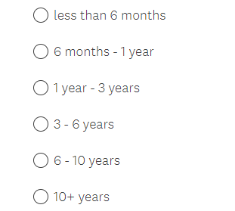

1. Please share your personal testimonial.
2. How would you describe the services or business you want to highlight?
3. Was there a specific department or individual whose service was exemplary? Tell us what they did to stand out.
4. Why did you choose to come to Kittson Healthcare?
5. Why would you recommend others in need to seek services at Kittson Healthcare?