**2022**

**Community Health Needs Assessment**

**& Implementation Plan**

For Kittson Healthcare & Kittson Public Health Department

(Formerly Kittson Memorial Healthcare Center)

***Mission Statement***

***Caring for family and friends, Kittson Healthcare collaborates***

***with others to ensure area residents have access to services***

***necessary to maintain their health and well-being.***

Introduction

According to the Internal Revenue Service, a critical access hospital organization is required to conduct a community health needs assessment (CHNA) every three years and to adopt an implementation plan (IP) to meet the community health needs as identified through the CHNA process.

Kittson Memorial Public Health Department is required to complete a community health assessment (CHA) and community health improvement plan (CHIP) every five years. The northwest corner of Minnesota is unique in that three of the five local public health departments that make up the Quin Community Health Board are based within critical access hospitals.

Therefore, the required plans were created in conjunction and in collaboration with each other. Other benefits included the ability to extend resources such as staff time and capacity while also preventing community survey fatigue, reflect a partnership, shared goals and the ability to meet time sensitive requirements as defined by the state of Minnesota and the Federal government.

In 2022, Kittson Healthcare is led by Gabriel Mooney, Chief Executive Officer and the Kittson Memorial Public Health Department is led by Jeanna Kujava, Public Health Director. Dr. Garth Kruger of EvaluationGroup, LLC, assisted with county wide demographic and health statistical data as well as a mentor to the public health director.

Overview

Kittson Healthcare is a non-profit, non-affiliated, locally owned and operated 501(c) 3 organization that has served the community since 1922. Kittson Healthcare is a federally designated Critical Access Hospital, a state-designated Sole Community Hospital and an Essential Community Provider. Kittson Healthcare has been the sole hospital in Kittson County since January 1995.

Kittson County is considered deep rural or a frontier county and has 1,098.8 square miles of land making it the 18th largest county in Minnesota (MN) by total area. Kittson County, MN is bordered by Pembina County, North Dakota to the west, Roseau County, MN to the east, Marshall County, MN to the south and Ontario, Canada to the north.

Kittson Healthcare’s primary service area includes Kittson County, a portion of northwest Marshall County and the northeastern border of North Dakota. According to the 2020 United States Census, the population of Kittson County was listed as 4207 citizens down from 4552 citizens in 2010. The 2020 MN employment rate measured 65% with a median household income of $77,720. The Kittson County employment rate measured 62.3% with a median

household income of $55,410. The largest age group living in Kittson County is age 19 to 64 years old and makes up approximately 54% of the population. The second largest age group living in Kittson County makes up 25% of residents and is age 65 and older. Over the past 12 months there were 42 recorded births to women living in Kittson County. The poverty rate for Kittson County is 11.9% compared to 9.3% for the state of MN. Out of the 11.9% of Kittson County residents living in poverty, 10.4% are children age 18 and under, 9.3% are individuals age 18-64 years and 19.6 % are age 65 years old and over. The population of Kittson County identify primarily as the race and ethnicity of white with the next largest race and ethnicity indicating Hispanic or Latino.

Kittson County is characterized by a predominately agricultural-based economy and small businesses. Current census data identify 144 small businesses with the majority employing less than 10 employees per business. Kittson Healthcare is one of the county’s largest employers with over 180 full time and part time staff. Kittson Healthcare operates a 15-bed licensed hospital offering inpatient, swing bed, observation beds and respite services. The facility provides 24-hour emergency care, endoscopy services, laboratory, x-ray, mobile diagnostic scanning (MRI and mammography), a 64 slice CT on site. Recently, in house ultrasound services were added and are available weekly. Kittson Healthcare provides cardiac rehabilitation services and has a contract with Blue Stone Therapies, Inc. for physical, occupational, and speech-language pathology services for therapy services. Kittson Healthcare operates an attached 50-bed nursing home including skilled care, an ambulance service, an 8-bed assisted living facility and two federally designated Rural Health Clinics located in Karlstad and Hallock. Kittson Healthcare also includes a hospital based certified Homecare agency and Local Public Health Department.

Currently, the Federal Health Resources & Services Administration (HRSA) has designated Kittson County, Minnesota as a geographic Health Professional Shortage Area. The specific shortage areas include primary care, mental health and dental health (data.HRSA.gov).

In response to past community needs assessments, Kittson Healthcare contracts with Alluma, a community mental health center for outreach mental health and mental wellness services for in person or telehealth counseling services. Kittson Healthcare employs a Certified Nurse Practitioner specializing in medication management of Psychiatric conditions. This service provider serves both Rural Health Clinics as well as providing outreach to neighboring LifeCare Medical Center in Roseau County. Recently, an additional Behavioral Health Therapist was added to meet the demand for counseling services in Kittson County and neighboring Roseau County. Based on community request for increased access to local specialty services, visiting providers in the following areas have an established presence within the Rural Health Clinic and include; Audio Care, Cardiology, Dermatology, Endoscopy, Obstetrics & Gynecology, Ophthalmology, Orthopedics & Sports Medicine, Podiatry, and Registered Dietician certified in diabetes care and as an education specialist.

The closest secondary hospital is located in Thief River Falls, MN or Grand Forks, ND, which is 75 miles from Hallock. The nearest tertiary hospital is located 150 miles away in Fargo, North Dakota. Travel to these locations during the winter months can be challenging, especially for our elderly population.

According to medical records data from 2021, Kittson County’s two major contributors of death are heart disease and cancer. In comparison to counties of similar size, additional areas of concern identified low rates of seasonal influenza coverage, high rates of children living in poverty and high rates of alcohol impaired driving deaths. Positive health outcomes to highlight in comparison to similar size counties identified few low birthweight infants, low rates of uninsured, and high rates of High School completion (2022 County Health Rankings & Roadmaps). Having access to a critical access hospital and primary care services within the service area is essential to preventing illness and disease, managing chronic diseases while aging in place, and responding to emergencies and stabilizing patients.

Since 1986, the federal law known as the Emergency Medical Treatment And Labor Act (EMTALA) governs the actions of Kittson Healthcare. This law was enacted to ensure public access to emergency services regardless of ability to pay and prevent the delay of treatment. Furthermore, Section 1867 of the Social Security Act requires Medicare participating hospitals providing emergency services to provide a medical screening examination or treatment for an emergency medical condition such as active labor regardless of ability to pay. Hospitals such as Kittson Healthcare are required to provide stabilizing treatment and if unable to or by patient request implement an appropriate transfer (cms.org).

The Community Care program is available through the business office to assist individuals with paying their healthcare bills for services rendered at Kittson Healthcare. The business office assists individuals with completing enrollment forms and are available for additional information about the program.

Methods

The 2022 CHNA/IP and CHA/CHIP process began by forming a workgroup within Kittson Healthcare led by Jeanna Kujava, Public Health Director. The workgroup members consisted of Gabriel Mooney, Chief Executive Officer, Jeni Schwenzfeier, Chief Financial Officer, Adam Maus, Chief Services Officer, Tawnya Sorenson, Hospital Director of Nurses, Rebekah Coffield, Director of Marketing & Communications and Jeanna Kujava, Public Health Director.

Facility survey subscription software Survey Monkey was used to populate the selected survey questions for distribution. The selected survey questions were part of a survey tool created and obtained from Dr. Garth Kruger, Ph.D. Director of EvaluationGroup, LLC. The survey tool was titled Northwest Minnesota Community Health Needs Assessment Survey and was designed to be used throughout the Quin Community Health Board’s five county area. The workgroup modified the survey to meet the needs of Kittson County. Multiple formats of the survey were

created such as QR code, web link and paper hard copies in order to capture a high rate of completion. First a postcard was sent every door direct to every resident living in Kittson County to introduce the purpose of the survey which included the QR code and web link. Approximately one month later, a paper hard copy of the survey was sent out every door direct to every Kittson County resident. The overall goal was to capture a minimum of 200 returned surveys.

Rebekah Coffield facilitated employee engagement activities to promote the completion of the survey in any of the formats during working hours. The survey was promoted at the Kittson County Fair booth and was made available in multiple formats. The Kittson Healthcare organization Facebook page was utilized to promote the CHNA/CHA process and call to action to the public to complete the survey.

Adam Maus was tasked with uploading the paper copy survey results into the software in order to have all of the results tabulated together using the Survey Monkey software. Education about the process was presented during the monthly department managers meeting in order to garner support and department level understanding of the CHNA/CHA process and purpose.

Gabriel Mooney provided feedback throughout the duration of the regularly scheduled workgroup meetings and attended as scheduling would allow. He provided financial oversight and direction alongside Jeni Schwenzfeier. Jeni Schwenzfeier, Chief Financial Officer, left the organization in August 2022 prior to the completion of the project.

A portion of funding utilized for this assessment was made available through a Health Resources & Services Administration, Rural Health Clinic, and Vaccine Confidence Grant along with in-kind staff time by members of the work group.

Quantitative

Kittson County, State of Minnesota, and National level data sources reviewed and considered within this assessment included:

* 2022 County Health Rankings
* U.S. Census Bureau and Data USA
* Health Resources & Services Administration HRSA.gov
* 2019 Kittson Healthcare Community Health Needs Assessment Implementation Plan
* 2017 Kittson County Adult Behavior Survey from EvaluationGroup, LLC
* 2017 Minnesota All Payer Claims Data
* 2016 Minnesota Student Survey
* Northwest Minnesota Community Health Needs Assessment Survey modified for Kittson County

Qualitative

In order to meet the Federal deadline and obtain board approval and adoption of the final CHNA/IP within the Kittson Healthcare Organizations Fiscal Year of September 31, 2021 through October 1, 2022, a large gathering was determined to be the best option for gaining community input on top priorities. The top 3 priorities would then serve as the goals for guiding the implementation plan.

In conjunction with the Homecoming football game held in Lancaster on Friday, September 16th, 2022 between Kittson County Central School and the Tri-County School/Marshall County Central Northern Freeze School, a voting tent was set up. A flier and poster describing the intent of the assessment and the call to action to vote for two top priorities was described. The flier was sent to the district office staff and athletic director of all three public school districts in the county that would be attending the football game. It was requested that this flier also be included within each school daily memo, included in their daily newsletter, and shared on the school social media page. An insert describing the intent of the assessment and the call to action to vote was printed in bright colored paper and stuffed into the football program to be distributed to each paying attendee of the football game.

As a thank you for voting, each Kittson County resident age 16 and older was eligible to receive a free taco-in-a-bag meal at the event’s concession stand. Utilizing the organization’s partnership with Lancaster Public School, Lancaster School Nutrition Services, and Lancaster Junior Class Advisor, the group agreed to provide the meal and the students to serve during the football game concessions. The Junior Class were provided a donation of $10 for each taco-in-a-bag coupon. Work group members set up the tent near the concession stand. Work group members provided directions about the voting process and guided attendees through the tent to place their two votes for their top priorities. After voting, a coupon ticket was provided for use at the concession stand to be redeemed that day only.

Utilizing the expertise of Dr. Garth Kruger Ph.D., EvaluationGroup, LLC, as well as a national, state and county level data review, over 174 survey results, and input collected following a community engagement event priorities were selected for the improvement plan.

Archival Data Findings

Kruger et. al., 2013 summarized over 20 public forum meetings that involved hundreds of people across northwest Minnesota. Overarching themes and concepts from those discussions are presented in Figure 1. Many of the community meetings highlighted affordable and accessible health care as a significant priority. However, affordable and accessible care is a complex and multi-faceted concern that also involves issues surrounding poverty, employment,

income, transportation and appropriate care to name a few. Some of the more specific points mentioned frequently at these meetings relative to this report include;

Health Insurance Cost

* Cost of healthcare is growing more unaffordable.
* Inability of employers to continue offering affordable coverage.
* Higher number of uninsured people not seeking medical care until it requires an ER visit.

Access to Appropriate Care

* Easier access to primary care providers – people want to get in quickly when they need to see their primary care provider.
* Maintaining qualified medical providers employed at the same facility long-term.
* Providing medical, dental, mental health for the uninsured, working poor and those who cannot take time away from hourly wage jobs to take children to regular appointments

Other Access Concerns

* Parents may not be able to meet costs for both medical (eyeglasses) and non-medical (winter wear) for their children.
* Could be attributed to lack of disposable income or lack of prioritization (or both).
* Access and affordability to exercise facilities and large group meeting spaces for health and wellness related activities
* People in the region go with untreated or unmanaged chronic health conditions

According to EvaluationGroup, LLC, the themes mentioned in the outline above have recurred in multiple datasets over the past decade and presented again in the data most recently collected.

Figure 1.

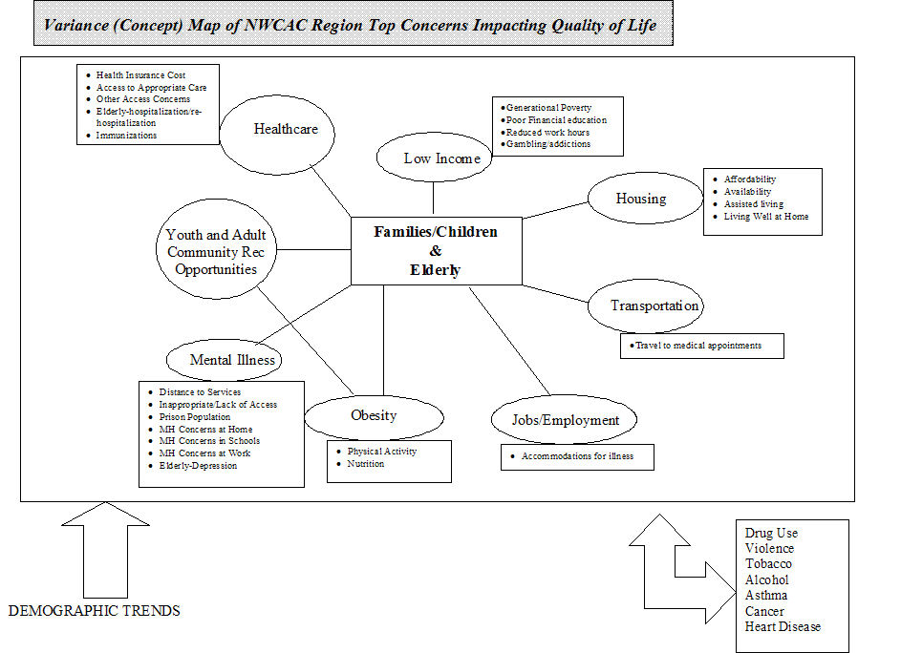

**Body Weight**

Survey respondents to the 2017 Northwest Regional Adult Behavioral Health Survey (NRABS) were asked to report their height and weight. From those data a Body Mass Index (BMI) was calculated[1]. As Figure 2 shows below, 70.9% of all individuals residing in the Quin county region are considered either overweight (37.4%) or obese (33.5%). This is a generally flat trend from 2014 and is higher than the state average of 64.5% (36.7% overweight; 27.8%, obese). To learn more, see <https://stateofobesity.org/states/mn>.

In terms of gender and age as related to weight, older males tend to be heaviest while younger females weigh the least (see Figures 2 and 3).

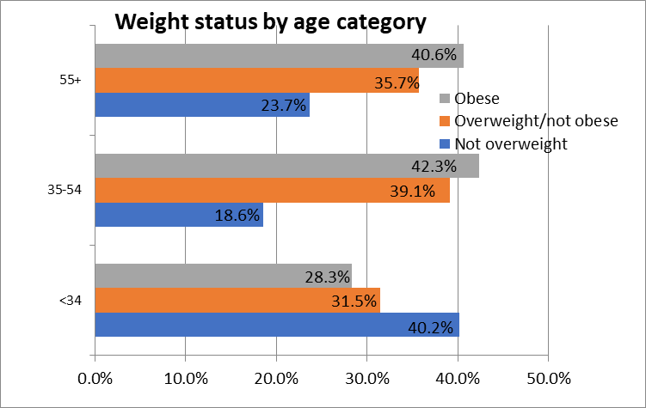

Figure 2.

The percentage of individuals who are overweight or obese increases with age. Results show that in the Quin region the 35-54 age group is the most overweight and obese.

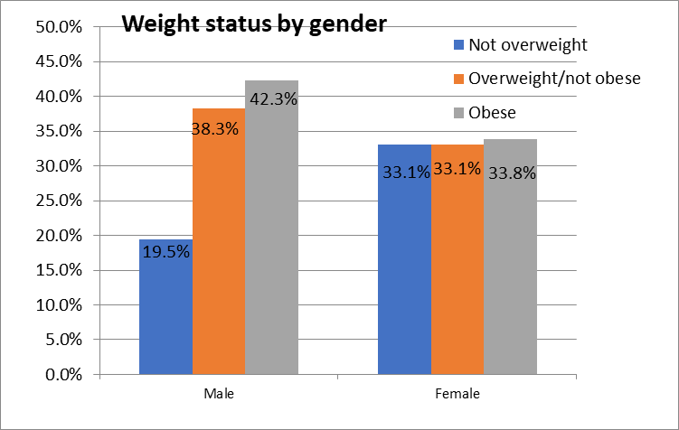

Figure 3.

Males tend to be 5-10% more overweight and obese than females.

According to the 2019 Minnesota Student Survey (MNSS), the percent of 11th grade students overweight and obese in the Quin CHB region is higher than the state average. Individual data for each county is listed in the table below.

|  |  |  |  |
| --- | --- | --- | --- |
|  | Obese | Overweight | Total |
| Red Lake | 23 | 15 | 38 |
| Marshall | 14 | 17 | 31 |
| Kittson | 17 | 13 | 30 |
| Roseau | 13 | 20 | 33 |
| Pennington | 19 | 13 | 32 |
| CHB | 15 | 17 | 32 |
| State | 11 | 14 | 25 |

**Physical Activity**

Participants were asked “During the past 30 days, other than your regular job, did you participate in any physical activity or exercises such as running, calisthenics, golf, gardening, or walking for exercise?” Thirty-four percent of survey respondents in 2017 indicated “no” whereas in 2014 only 26% said no. The state average on this measure is approximately 18%.[2],[3] Households earning $35k or less reported getting less physical exercise (54%) than households earning $75k or more (76%).

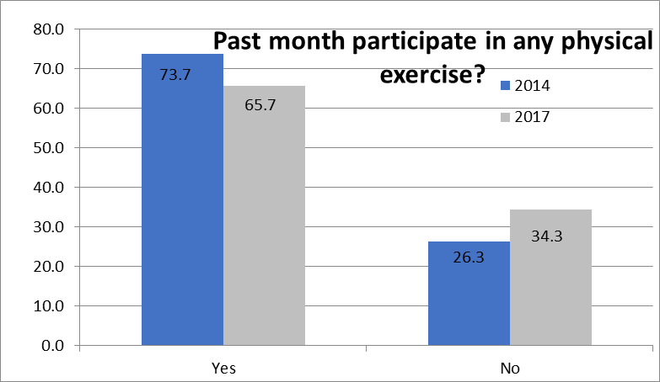

Figure 4

Attainment of Physical Activity Guidelines (PAG) were assessed. This was achieved through a series of questions examining the extent of moderate physical activity (30 minutes/day for /5+ days) and vigorous physical activity (20 minutes a day for 3+ days).[4]

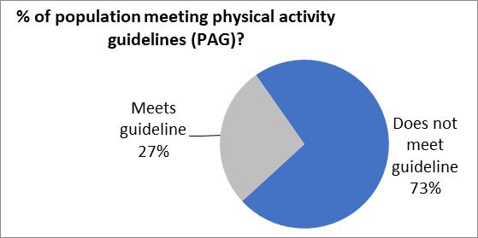

Figure 5

Only an estimated 27% of individuals are getting their recommended levels of physical activity. This is far lower than the average rate of 55% of all Minnesotans. Workplace wellness initiatives are popular efforts (and as the data in Figure 6 suggest) they are focused on a population that is lower in their attainment of Physical Activity Guidelines relative to other demographic groups (e.g. students, unemployed, homemakers).

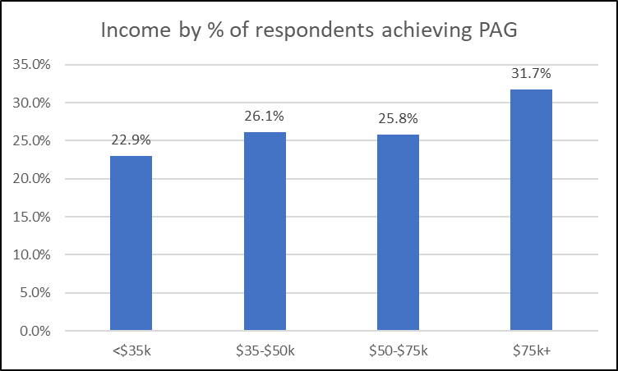

Figure 6

Weather was noted as the greatest reason for lack of physical activity (69%) followed by ‘lack of time’ (66%). All other reasons were endorsed approximately 20% of the time (poor maintenance of sidewalks or walking paths/trails, public facilities not available when I want to use them, fear of injury, long-term illness, injury or disability, traffic problems, not having sidewalks or walking paths/trails).

**Elevated Cholesterol**

As identified in the 2017 MN All Payers Claims Database, Kittson County residents displayed a prevalence rate of high cholesterol that was between 5-15% higher than the statewide rate. (see Figure 7).

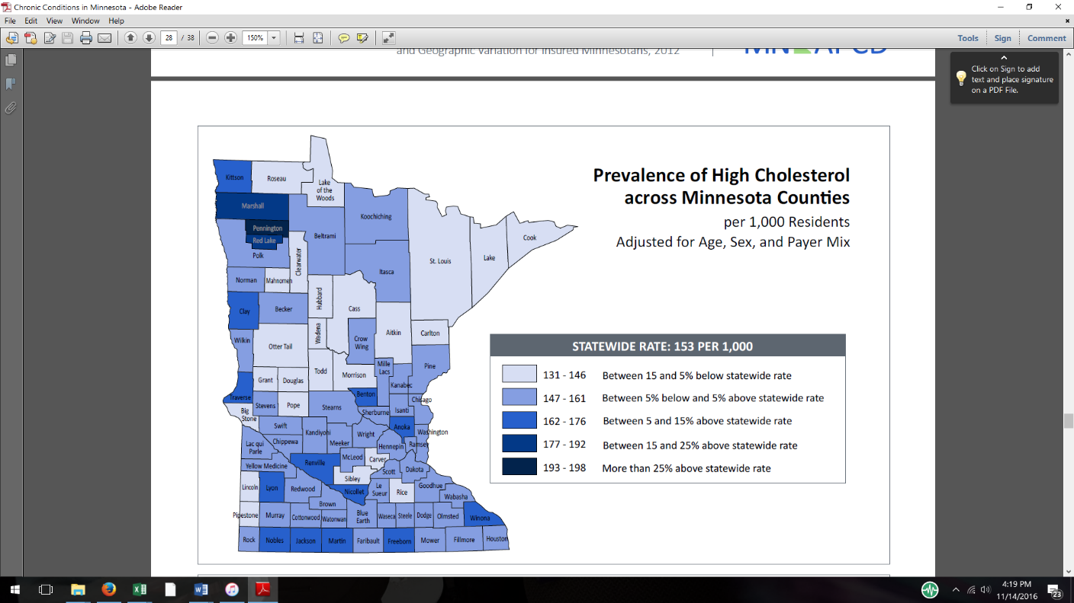

Figure 7

Source: MN All Payers Claims Database

**Elevated Blood Pressure**

The MN APCD study indicated that people in Kittson County received treatment for blood pressure in 2012. Figure 3 below reflects that residents of Kittson County range between 5% and 15% above the statewide rates of elevated blood pressure.

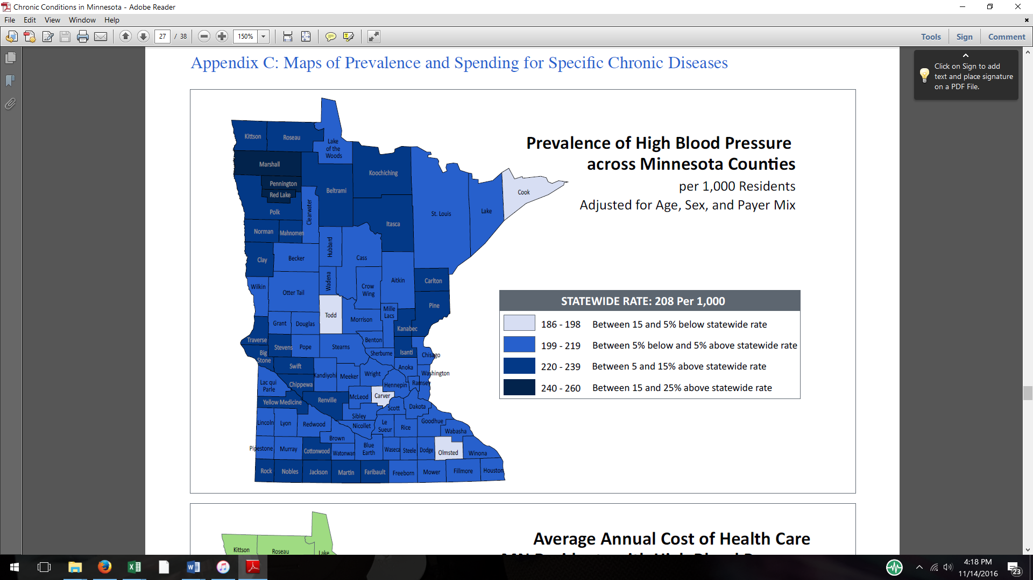

Figure 8

Source: MN All Payers Claims Database

**Heart Health**

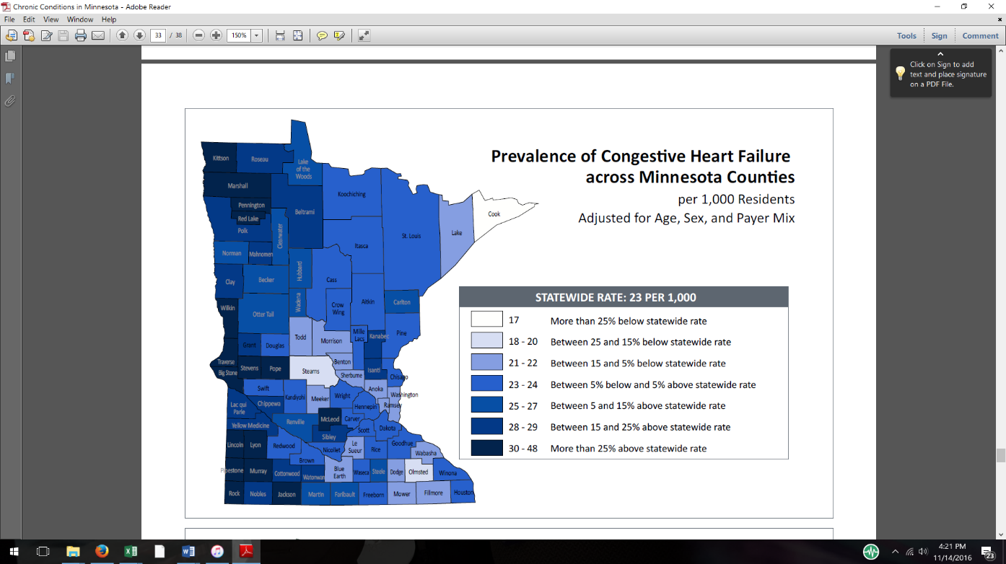The combination of being overweight, high blood pressure and elevated cholesterol create the perfect storm for heart disease and failure. Kittson county along with Marshall county are among the worst counties in the state for rates of congestive heart failure. According to the MN APCD, Kittson county had healthcare claims submitted for congestive heart failure at more than 25% above the state rate (see Figure 9). Congestive Heart Failure occurs when the heart muscle cannot pump enough blood and oxygen through the body resulting in a buildup of fluid in the legs, lungs, or other tissues. In the U.S., heart disease is the leading cause of death (cdc.gov).

Figure 9

Source: MN All Payers Claims Database

**Diabetes**

The MN APCD Database study indicated that Kittson county ranged between 5 and 15% above the statewide rates of diabetes treatments reimbursed during that similar time frame as shown in Figure 10 below.

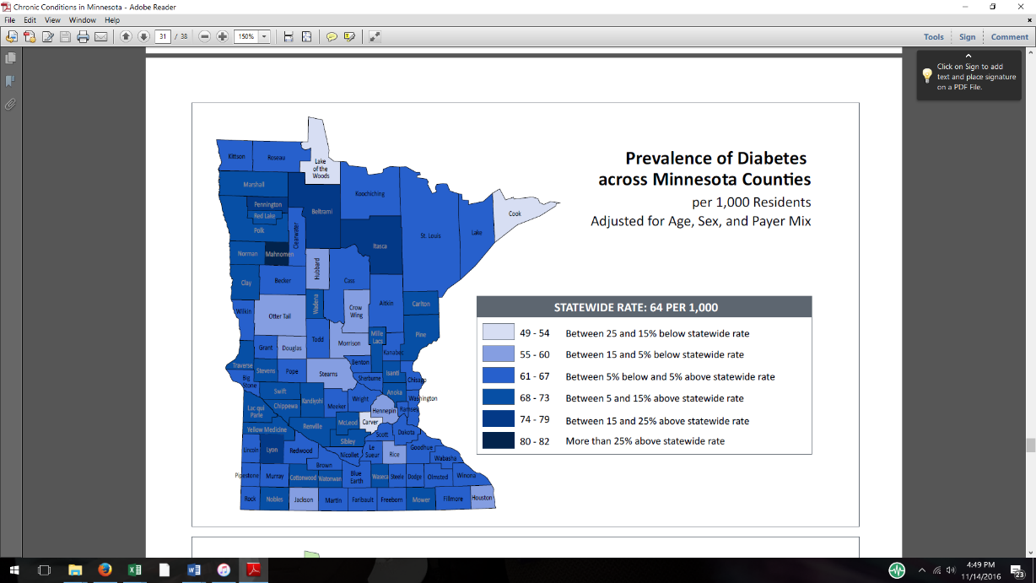

Figure 10

Source: MN All Payers Claims Database

**Tobacco Use**

Approximately 9.4% of all adults in the Region are smokers. This is 5.5% lower than 14.9% found three years previously and suggests that significant positive impacts may be the result of numerous prevention efforts. Current smokers are split equally across genders but differ significantly by income and education. Individuals with less than $34,000 annual household income had nearly three times the rate of smoking compared to all other income classes (17.2% vs. 5.7%). And only 2.4% of those with 4-year degrees smoked compared to all other educational demographic groups which smoked at approximately 13%.

Roseau County has the highest smoking rates at 10.5%. This is a significant decrease from 2014. Further, in the five-county region, 35.8% of current smokers indicated that during the past 12 months they had stopped smoking for one day or longer because they were trying to quit. This is down from 55.3% of smokers from 2014. It is unclear why this might be the case.

Table 1

|  |  |  |  |  |  |  |  |
| --- | --- | --- | --- | --- | --- | --- | --- |
|  | **Quin CHB Region** | **Marshall County** | **Kittson County** | **Pennington County** | **Red Lake County** | **Roseau County** | **MN State** |
| **Current smokers 2014** | 14.9 | 11.6 | 8.0 | 13.5 | 15.5 | 20.7 | 14.1 |
| **Current smokers 2017** | 9.4 | 9.6 | 8.6 | 8.2 | 9.5 | 10.5 | 13.8* |
| **Net increase/decrease** | -5.5 | -2.0 | +.6 | -5.3 | -6.5 | -10.2 | 0.3 |

Results also found that 7.3% of adults are smokeless tobacco users. Of the 85 smokeless tobacco users in the sample, all but one of them are males. E-cigarette use is even lower at 1.2%. Statewide surveys estimate adult e-cigarette use in Minnesota at 6%[5]. Northwest Minnesota estimates range from 2-6% from the 2014 MN Adult Tobacco Survey.[6]

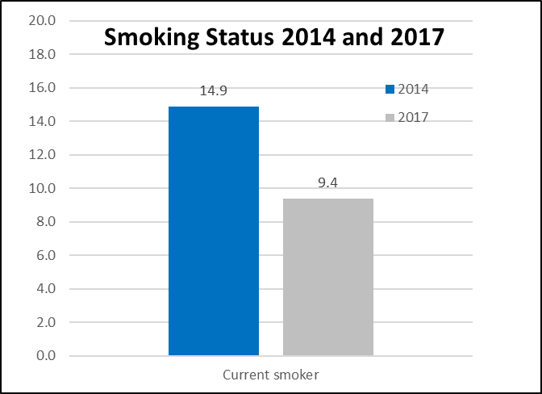

Figure 10

**Alcohol Use**

Participants were asked “during the past 30 days, have you had at least one drink of any alcoholic beverage such as beer, wine, a malt beverage or liquor?” Respondents indicated that 66.5% of them had consumed alcohol. A further twenty-two percent of respondents indicated that alcohol had a ‘harmful effect’ on themselves or a family member. Harmful effects seemed to be modestly impacted by income, educational level and age. For households with less than $50k income, 27% were adversely impacted by alcohol versus 20.5% (households >$50k). Respondents aged 34 or less reported 16% were adversely impacted compared to 24% of those aged 35+. Similarly, 25.8% of individuals with a high-school diploma or less experienced harmful effects compared to 18% of those with greater education.

Drinking percentages were split evenly across the genders, however 72% of individuals younger than 55 reported drinking versus 58% for all other age groups. Seventy-five percent of individuals from higher income households (>$50k) reported drinking over the past 30 days compared to 46% of those earning $34k or less. Furthermore, individuals with an Associate’s degree or higher educational attainment were more likely to report alcohol consumption over the past 30 days (75%) than those with a GED or less (55%). It should be noted that ‘any drinking’ does not mean problem drinking. Future surveys should include questions pertaining to binge drinking as were included in 2013 to get a better handle on dangerous drinking.

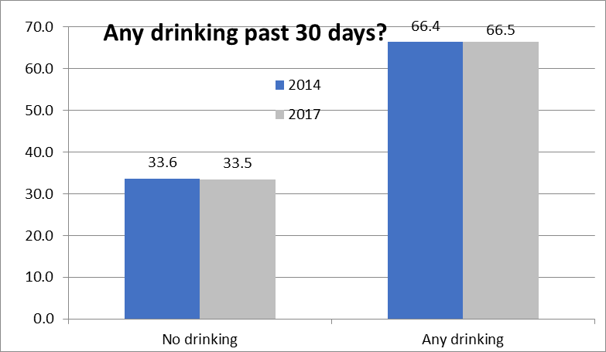

Figure 12

**Mental Health**

Over the past 30 days, nearly 22% of respondents expressed feelings of hopelessness, anxiety or loss of interest in things they used to enjoy.This figure jumps to 30% for those who are 34 years old or less and compares to 15% for those aged 55 or older.

Figure 13

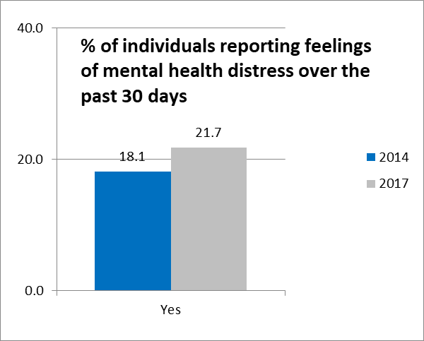

**Mental Health**

* Approximately 9.2% of individuals living in the Quin CHB region self-report having Fair or Poor general mental health at the time of the survey.
* 23.1% have been told at some point in their lives by a healthcare professional that they have a mental health concern.
* 17% have delayed getting mental health treatment when it was needed.
  + Of this group, the delay occurred for a variety of reasons, including fear of getting treatment (28%), perceived lack of severity (27%), ‘did not know where to go’ (27%), cost (15%), could not get an appointment (14%), and deductible too expensive (11%).

**Medical Care**

Approximately 80% of area residents reported having a medical checkup over the past year. Seventeen percent delayed seeking medical care over the past 12 months when they felt they needed it. The primary reason for not seeking care was cost (46.4%) and high deductible (39.7%). Instead of people not seeking medical care because of no health insurance, many may not be seeking medical care because the deductibles and associated costs are high.

Implementation Strategy Recommendations

Kittson Healthcare and Kittson Healthcare Public Health Department will lead the implementation plan for improving the health of the community by monitoring and measuring progress and impact of objectives, modify and adjust objectives as needed to align with required state standards and metrics, and identify opportunities for engaging additional partners and the community over the next three years. While multiple health measures were identified and will continue to be explored, the top community concerns for the 2002 implementation plan as voted upon by community members included;

* Stress and anxiety management
* Heart Health
* Weight management
* Access to Healthcare Services & Resources

In order to move forward, it will be essential to continue the community conversation related to improving the overall health of Kittson County. While this implementation plan has established steps toward improved health it will require a personal commitment by each individual to engage in the process in order to achieve improved physical and mental health of Kittson County.

The following tables include multiple strategies in order to achieve the priority health need. There are strategies that are shared among multiple goals with the intent to weave mental health and improved access throughout.

| **Fiscal Year**  **October 1, 2022 thru September 30, 2023** | **Health Need: Stress and Anxiety Management** | | | | |
| --- | --- | --- | --- | --- | --- |
| **Anticipated Impact (Goal)** | The initiatives to address the need for stress and anxiety management will result in: early identification and treatment of individuals reporting high levels of stress and anxiety described as interfering with one’s life; increase knowledge about how to access and navigate the health care system; public or private health care coverage including telehealth. Increase knowledge about the risks of substance use to manage stress and anxiety. | | | | |
| **Strategy or Program** | **Summary Description** | **Progress Tracking by quarter** | | | |
| Oct, Nov, Dec  0% | Jan, Feb, Mar.  0% | Apr, May, June  0% | Jul, Aug, Sept.  0% |
| Promote mental health as health and local health related resources and services. | Facilitate annual mental health/health services expo. Invite and highlight local resources. Promote mental health as health through media promotions. Increase knowledge about lifestyle choices. Distribute facility magnet every 2 years listing providers and retail pharmacy contact information. Distribute facility newsletter biannually including provider listing and retail pharmacy services. |  |  |  |  |
| Educate the community including employees about how to schedule an appointment with a provider. | Schedule an appointment at rural health clinic with primary care provider located in Hallock or Karlstad within 1 month of requesting an appointment. Consider options for expanding capacity for additional appointments if unable to meet goal. |  |  |  |  |
| Promote the Employee Assistance Program (EAP) The Village resource with all employees. | Include EAP information and education upon hire and quarterly thereafter to employees utilizing methods such as payroll stuffers, employee social media page and The Village newsletter. Host onsite walk in or by appointment EAP representative office hours annually. Provide The Village Supervisor specific newsletter to mangers and leadership biannually. |  |  |  |  |
| Assure access to an appointment with a healthcare provider or mental healthcare provider in Kittson County. | Schedule an appointment with mental health or specialty provider within one month of request. Explore options to expand telehealth and e-visits to reduce travel or mobility barriers. Promote and educate on the use of My Chart features to communicate with healthcare providers and to request an appointment. |  |  |  |  |
| **Planned Resources** | The hospital will provide advanced practice nurse practitioner certified in psychiatric specialty and behavioral health therapist. The hospital will provide IT professional, outreach communications and program management support. The public health department will provide in-kind outreach, education and support. The public health department will serve on the Northwest 8 Adult Local Advisory Council and the HOPE Coalition to promote mental health, wellness and recovery throughout Kittson County. Collaborate and extend capacity by partnering with Alluma, LPCC Mental Health Professional. | | | | |
| **Planned Collaborators** | Life Care Health Center, Alluma, Sanford Behavioral Health-Thief River Falls, Northwest 8 Adult Local Advisory Council, Kittson County Social Services Department, HOPE Coalition, Kittson Public Health Department. The Village, Adult/Child Crisis Support Line: 1-800-282-5005 or Text: MN to 741741 | | | | |

| **Fiscal Year**  **October 1, 2022 thru September 30, 2023** | **Health Need: Heart Health** | | | | |
| --- | --- | --- | --- | --- | --- |
| **Anticipated Impact (Goal)** | The hospital initiatives to address the need for improving cardiovascular health or overall heart health will result in: early identification and treatment of individuals, increased knowledge about how to access and navigate the health care system; public or private health care coverage including telehealth, increased knowledge related to tobacco cessation including e-cigarette and spit less tobacco products. | | | | |
| **Strategy or Program** | **Summary Description** | **Progress Tracking by quarter** | | | |
| Oct, Nov, Dec  0% | Jan, Feb, Mar.  0% | Apr, May, June  0% | Jul, Aug, Sept.  0% |
| Promote Mental Health as Health | Facilitate an annual Mental Health/Health Services Expo highlighting local resources, promote mental health as health through media promotions. Increase knowledge about the impact of lifestyle choices upon health. |  |  |  |  |
| Outreach Providers or Visiting Specialty Providers | Provide healthcare appointments to all requesting individuals in rural health clinics located in Hallock and Karlstad to meet the demand for appointments including telehealth. |  |  |  |  |
| Raise awareness about the Cardiac Rehabilitation Program | Promote the cardiac rehabilitation program and the benefits there media campaign once a year. Review and streamline referral process for patients to receive cardiac rehabilitation annually. Assure appropriate staffing levels to meet patient demand. Assure appropriate equipment to support optimal programs. |  |  |  |  |
| Raise awareness about the availability of and the capacity of a Registered Dietician | Provide and promote appointments available with registered dietician for weight management and lifestyle coaching once a year. Review and streamline referral process for patients to meet with registered dietician. Assure appropriate staffing levels to meet patient demand. Educate primary care providers about the role of the registered dietician once a year and explore opportunities for health management. |  |  |  |  |
| **Planned Resources** | The hospital will provide registered nurse, registered dietician, partnership with outreach providers, The hospital will provide outreach communications and program management support for these initiatives. The public health department will provide outreach and support for these initiatives. | | | | |
| **Planned Collaborators** | The public health department will provide in-kind services. The public health department will partner and serve on school based wellness committees as able, collaborate with Statewide Health Improvement Program initiatives related to healthy eating and being active. Partner with school based community education, fitness center, employee wellness initiatives and local health coaches. | | | | |

| **Fiscal Year**  **October 1, 2022 thru September 30, 2023** | **Health Need: Body Weight Management** | | | | |
| --- | --- | --- | --- | --- | --- |
| **Anticipated Impact (Goal)** | The hospital’s initiative to address body weight management will result in: early identification and treatment of individuals outside of the normal body mass index, increase knowledge about how to access and navigate the health care system; public or private health care coverage including telehealth, increase knowledge regarding the benefits of normal body mass index, assess for food insecurity and promote local resources and services. | | | | |
| **Strategy or Program** | **Summary Description** | **Progress Tracking by quarter** | | | |
| Oct, Nov, Dec  0% | Jan, Feb, Mar.  0% | Apr, May, June  0% | Jul, Aug, Sept.  0% |
| Promote Mental Health as Health | Facilitate annual mental health/health services expo. Invite and highlight local resources. Promote mental health as health through media promotions. Increase knowledge about lifestyle choices. Distribute facility magnet every 2 years listing providers and retail pharmacy contact information. Distribute facility newsletter biannually including provider listing and retail pharmacy services. |  |  |  |  |
| Promote preventative screenings and the benefits of a primary care provider | Increase knowledge about routine preventative screenings through middle age. Recognize and promote screenings unique for optimal men’s health and women’s health through media campaigns. |  |  |  |  |
| Raise awareness of the impact of nutrition on health. | Support area farmer’s markets as a source for fresh fruit and vegetables. Host a Grab and Go group education opportunity for employees and the community with a nutrition focus. |  |  |  |  |
| Raise awareness of the impact of physical activity on health. | Support healthy breaks for employees and the community to increase physical activity. Host a Grab and Go group education opportunity for employees and the community with a focus on physical activity biannually. Promote physical activity in the newsletter and social media biannually. |  |  |  |  |
| **Planned Resources** | Kittson Healthcare will provide healthcare providers, Big Stone Therapy providers, Mental Health providers, Registered Dietician, school based community education programs, fitness centers, employee wellness initiatives and health coaches. The public health department will provide in-kind services, partner and serve on school based wellness committees as able, collaborate with Statewide Health Improvement Program initiatives related to healthy eating active. | | | | |
| **Planned Collaborators** | Experience Fitness, Statewide Health Improvement Program, Employee Wellness Initiatives, School Districts, Health coaches, Karlstad Fitness Center, Farmer’s Markets, Food Pantry, City Administrator or City Clerk, Kittson County Enterprise, Northstar News. | | | | |

# EvaluationGroup, LLC

**Quin Community**

**Health Services**

**2017**

**Northwest Region**

**Adult Health Behavior Survey Summary**

Kittson County Report

April

2018

Authored by

Garth Kruger, Ph.D.

EvaluationGroup, LLC * 29337 310th Ave NW * Warren, MN 56762

Tel (218) 437-8435 * e-mail *gkruger@evaluationgroupllc.com*

**Executive Summary**

**Weight**

73.8% of all individuals residing in Kittson County are considered either overweight (33.2%) or obese (40.6%).

* + - 74.9% of all individuals residing in Kittson County are considered either overweight (40.6%) or obese (34.3%) this is much higher than the state average of 64.5% (36.7% overweight; 27.8%, obese).
      * The percentage of individuals who are overweight or obese increases with age
      * Males are more obese than females.

**Physical**

**Activity**

Across Kittson County only an estimated 30% of individuals are getting their recommended levels of physical activity, far lower than the state rate of 55%.

* + - Males tended to meet Physical Activity Guidelines more than females (34% vs. 26%)
    - 45.5% of those age less than 34 achieved PAG compared to 25% age 35+.
    - Lack of time is cited by 61% of respondents as the second largest barrier to getting more exercise after adverse weather (71%) and lack of public facilities available when they want to use them (30%).

**Fruit/Veg**

Two-thirds of the population in Kittson County consume adequate amounts of nutritious food.

* + - The problem may be in consuming too many calories, not a lack of nutritious food.
    - Both fruits and vegetables are consumed at generally similar rates with vegetables having a slight edge.

**Tobacco**

Approximately 8.6% of all adults in Kittson County are smokers.

* + - This is 0.6% higher than 8% found three years previously but is still the lowest rate in the Quin CHB region.
    - Because of low frequency counts in each cell, it was difficult to determine demographic characteristics of smokers in Kittson County.
      * Individuals with less than $34,000 annual household income have nearly three times the rate of smoking compared to households earning $75k+ (5% vs. 15%).
      * In addition, very few individuals with 4-year degrees smoke compared to all other educational demographic groups, which smoked at double or triple the rate.

**Alcohol**

The percentages of individuals that report drinking at least once/past 30 days was 68.5%, with males drinking at a slightly higher rate (74% vs 64% female).

* + - * 76% of individuals < 55 y/o reported drinking versus 61% for all other age groups.
      * 92% of individuals from higher income households (>$75k) reported drinking over the past 30 days compared to 54% of those earning $34k or less.

**Mental**

**Health**

26% of respondents had been told by a healthcare professional that they had a mental health concern at some point in their lives.

* + - Over the past 30 days, 13% of respondents expressed feelings of hopelessness, anxiety or loss of interest in things they used to enjoy.

**Recommendations**

* Health planners should continue to focus resources on areas that develop and encourage physical activity across working adult populations.
* Prevention efforts need to help people find time in their day to get some physical activity.
  + Assist in structuring environments to enhance physical activity.
* Track binge drinking as in the 2013 survey.

Kittson County, Minnesota, Geographic Location

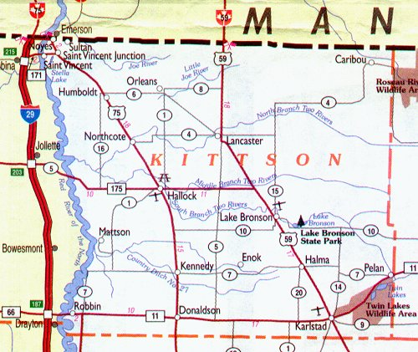

County location in the state of Minnesota:

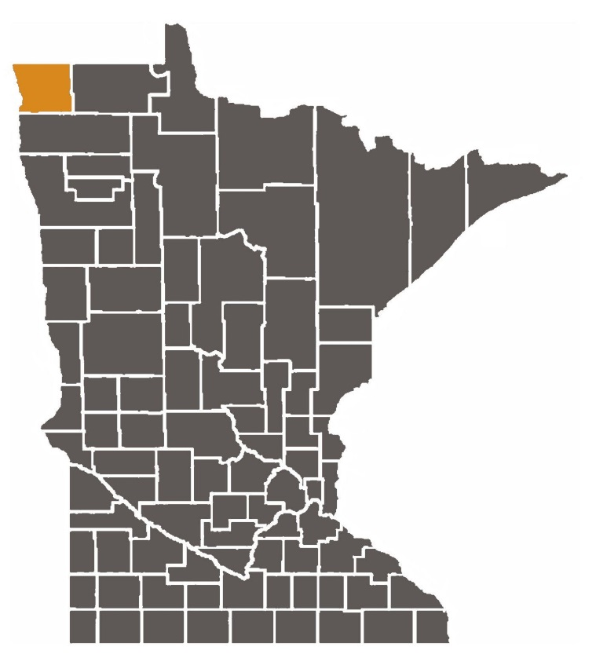

1. There are some exceptions to be considered in using BMI to accurately assess the health of individuals; however it is assumed here to be a generally accurate measure for the body mass composite a population.
2. <https://stateofobesity.org/physical-inactivity/>
3. <https://nccd.cdc.gov/dnpao_dtm/rdPage.aspx?rdReport=DNPAO_DTM.ExploreByLocation&rdRequestForwarding=Form>
4. *Moderate exercises are defined as those that “cause only light sweating and a small increase in breathing or heart rate, and vigorous are those that “cause heavy sweating and a large increase in breathing or heart rate. To learn more see* <http://www.health.gov/paguidelines/guidelines/summary.aspx>
5. <http://www.health.state.mn.us/ecigarettes>

   * Minnesota Adult Tobacco Survey, 2018
6. <http://www.mntobacco.nonprofitoffice.com/vertical/Sites/%7B988CF811-1678-459A-A9CE-34BD4C0D8B40%7D/uploads/MATS_2014_Technical_Report_Final_2015-01-21.pdf>